Daniel Drache
Has Populism Won?
The War on Liberal Democracy

“Has Populism Won? The War on Liberal Democracy is brilliantly lucid in its account of the global upsurge of right-wing populism. Here, the fate of liberal democracy is analyzed against a gathering storm of powerful right-wing populist movements, all motivated by the politics of grievance, all moving from country to country, continent to continent at the speed of (digital) light, and all bent on undermining, discrediting, and eliminating democratic discourse. In explicit detail and with great lucidity, Has Populism Won? explores the many different varieties of contemporary populism, their entanglements, and their likely political trajectories. A must-read for understanding 21st century politics.”

– Arthur Kroker, Professor Emeritus, University of Victoria

“Populism is a way of framing a political message that places grievance and rage front and center. It also tells the listener who to blame. Every populist movement imagines that it speaks for the true people, and it opposes evil elites. Who these evil elites are depends on the moment: They could be cultural elites like filmmakers or the political class in Ottawa, Washington, Delhi or Brasilia. Taking a hard look at the global insurgency across 35 countries and the toxic dangers that the far right poses to liberal democracy across the globe, we hope this book will be valuable for everyone who has been watching the populist insurgency with growing anxiety. Defending democracy starts with unmasking those who would destroy it.”

BIOGRAPHY

Political scientist and author Daniel Drache has documented and mapped hyper-globalization and its consequential impacts on communities and peoples for more than two decades. He has published over 20 books on global political economy, Canada-US relations, NAFTA, the iconography of social movements, defiant publics, trade governance, and social media. A Prof. emeritus and Department of Politics and Research fellow at the Robert Centre for Canadian Studies at Toronto’s York University, Drache has also taught in France, India, Argentina, South Korea, Australia, Brazil and China.

ABOUT THE BOOK

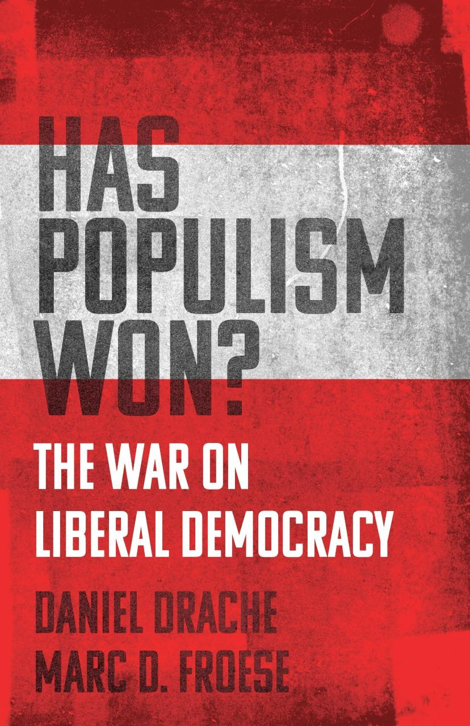
From Trumpian America to Putin’s nationalist Russia, and Poland to the Philippines, rapid change and rising inequality have fueled a retreat into tribalist nationalism fed by a fear of being left behind. Has Populism Won? The War On Liberal Democracy (ECW Press, Oct. 18, 2022) by Daniel Drache and Marc D. Froese, examines exactly how populist leaders reach into this fear, using it as a lever to power with empty promises of looking out for the little person and promising a return to national greatness. This is happening in countries spread across the globe and the political spectrum, arising in the right and the left alike, and recently brought into harsh relief against Putin’s brutal invasion of Ukraine. So why are we so susceptible to this pernicious political style at this moment? How did we get here? And more importantly, will we get back to more even-handed governments?

Has Populism Won? is written as a warning about the toxic impact of hate speech and the big lie on liberal democracy.

“This book is special because it looks at the big picture, as well as is comparative and evidence-driven,” Drache says. “The narrative has many examples of populist leaders and examines the similarities and differences of these leaders, illiberal movements, conservative ideas and radical goals. It looks at the public policy record of the hard-right populists with respect to foreign policy, COVID-19, global governance and the motivation of rank-and-file activists. The appeal and attraction of authoritarian populism is as much psychological as economic and political, stoking anger and rage against the political class and the state.”

Filled with original research, political scientists Drache and co-author Marc D. Froese have written a chilling, compelling analysis of the rise of populism, and reveal what it will take to douse the flames. This is an essential read for anyone concerned about the encroachments on freedom and the rule of law around the world.

INTERVIEW TOPICS

- How and why populism is the new globalism
- How the “radical right” may face a crisis of legitimacy
- How populism may lead to more surges of violence
- The possibility of a new civil war
- How right-wing populists use gerrymandering and the Supreme Court to gain and maintain power
- What opponents of right-wing populism must do to regain power and restore democracy
- Why voters in numerous countries, not just the United States, have embraced right-wing populism
- How the criminalization of abortion impacts voters
- Why authoritarian populism won’t self-destruct like other political and social movements
- How the COVID-19 pandemic impacted populism
- Why Russia’s invasion of Ukraine hasn’t toppled populism’s pull globally
- How inequality breeds populism
- How voters’ anger towards political and economic elites breeds populism
- What has made populism so successful thus far
- What really drives the populist insurgency with voters
- The differences between populism, nativism and nationalism—and why it matters
- What Viktor Orbán and Vladimir Putin have in common
- The future of authoritarian populism
- The difference between right- and left-wing populism
- Four lessons that populism has taught us
- The growing convergence between cross-border populism in Canada and the US

NOTABLE ENDORSEMENTS

“Many factors are propelling the populist wave rolling through political systems around the world. This compelling, erudite, and accessible volume clarifies them in comparative context and sets the stage for urgently needed responses. Drache and Froese provide a passionate and convincing warning of the dangers immediately ahead for all of us. If you only read one book this year on the turbulent politics of our time, this should be it.” —Louis W. Pauly, J. Stefan Dupré Distinguished Professor of Political Economy, Munk School of Global Affairs and Public Policy, University of Toronto

“Daniel Drache and Marc Froese have written an essential primer on modern populist authoritarianism. They unpack its origins, its internal dynamics, and its likely evolution, demonstrating why it poses a mortal threat to liberal democracy. We can’t defend the freedoms and institutions we treasure if we don’t accurately understand why they’re in danger. This book is a vital contribution to that defense.” —Thomas Homer-Dixon, Director of the Cascade Institute, Royal Roads University, Victoria, British Columbia

“A fascinating and necessary look at ‘the anti-system vote’ around the world and what it means for the future of democracy. Populism, and the Ur-fascism it so often falls into, isn’t done with us yet.” —Stephen Marche, author of The Next Civil War

CONNECT

Connect with Daniel Drache:
Official Site: www.danieldrache.com
Twitter: @danieldrache
Texting: 416-450-0100

